JOURNAL ON
PEARLLS

Volume 1, Number 1
April 2026
E-ISSN:

Title Maximum 12 Words (13pt Bold)

Author Name¹, Author Name² (12pt Bold)
¹First Author Affiliation (institution/college) (11pt)
²Second Author Affiliation (institution/college) (11pt)
Email: name@address.com (email of the first author/corresponding author) (11pt)
WhatsApp Number: 0000 (Not for publication, only for correspondence with the editor)

Keywords | Abstract
Format, journal, template | Abstract and keywords written in two languages (Indonesian and English). The length of each abstract 100-150 words, accompanied by a number of 3-5 words keyword. Abstract minimal contain the objectives, methods, and results of research. Abstract and keywords written in two languages (Indonesian and English). The length of each abstract 100-150 words, accompanied by a number of 3-5 words keyword. Abstract minimal contain the objectives, methods, and results of research. Abstract and keywords written in two languages (Indonesian and English). The length of each abstract 100-150 words, accompanied by a number of 3-5 words keyword. Abstract minimal contain the objectives, methods, and results of research.
Kata kunci | Abstrak
Format, jurnal, template | Abstrak dan kata kunci ditulis dalam dua bahasa (Indonesia dan Inggris). Panjang abstrak 100-150 kata, disertai kata kunci 3-5 kata. Abstrak minimal berisi tujuan, metode, dan hasil. Abstrak dan kata kunci ditulis dalam dua bahasa (Indonesia dan Inggris). Panjang abstrak 100-150 kata, disertai kata kunci 3-5 kata. Abstrak minimal berisi tujuan, metode, dan hasil. Abstrak dan kata kunci ditulis dalam dua bahasa (Indonesia dan Inggris). Panjang abstrak 100-150 kata, disertai kata kunci 3-5 kata. Abstrak minimal berisi tujuan, metode, dan hasil. Abstrak dan kata kunci ditulis dalam dua bahasa (Indonesia dan Inggris). Panjang abstrak 100-150 kata, disertai kata kunci 3-5 kata. (ukuran huruf 11 pt spasi 1).

Introduction (12 pt bold)
The introductory section contains background, state of the art, research gaps, and research objectives. Introductory are presented in an integrated manner in paragraphs. The submitted article has never been published and is not offered to another journal. The length of the article is 5,000 - 8,000 words written in English. You must be writing according to the Author Guidelines. The systematics of the research articles are the title, author's name (along with the institution's address and e-mail address), abstract (with keywords), introduction, method, results and discussion, conclusion, and references. The title of the article is no more than 12 words. The name of the author of the article is listed without an academic degree, accompanied by the name of the institution the e-mail of the author, placed under the title of the article. If more than one person writes the manuscript, the e-mail listed is only the e-mail of the main author (correspondence author). See also AUTHOR GUIDELINES (12 pt 1.15 spacing).

Method (12 pt bold)
The method contains an explanation in the form of paragraphs about research design, data sources, data collection techniques, and data analysis. (12 pt 1.15 spacing).

Results and Discussion (12 pt bold)
The research results and discussion contain an explanation of the results of the analysis related to the research objectives. The discussion includes an analysis of the results and discussions with theories and similar research results. This section can be completed with tables or figures related to the discussion. Example of a table:
Table 1. Community Characteristics
No. | Age (Years) | Education | Occupation
1 | 20 | Senior High School | Entrepreneur
2 | 30 | Bachelor | Civil servant
Source: Research results

Figures included in the manuscript are an essential part of the research results. The figure's color must be clear, and the size is correct. Sample of figure:

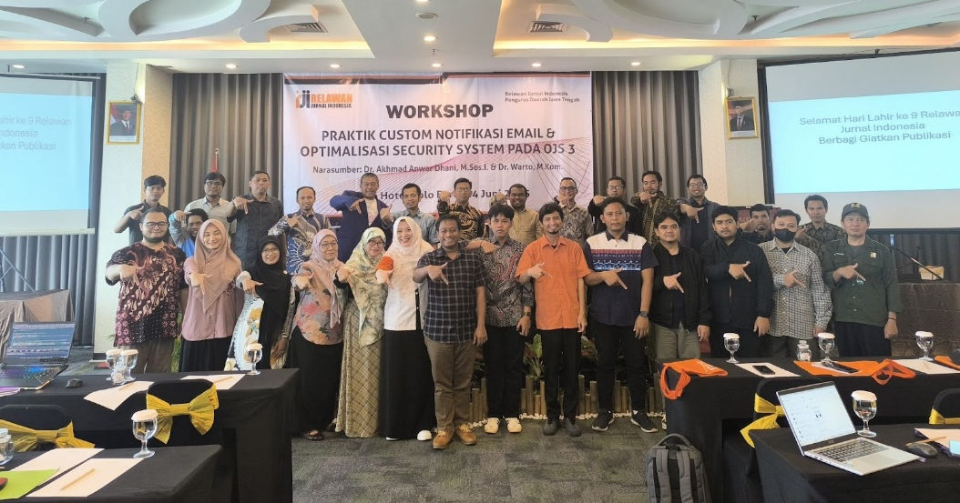
Source: Research results
Figure 1. Image caption

Conclusion (12 pt bold)
The conclusion contains answers to the purpose of writing the article and is presented in paragraphs instead of bullet points. (12 pt 1.15 spacing).

References (12 pt bold)
The reference list is recommended using reference management tools (Zotero, Mendeley, and others). The reference list is arranged alphabetically referring to APA Style 6th edition. Example:

Book with a single author
Eriyanto (2014). Analisis Jaringan Komunikasi. Jakarta: Prenada Media Group
Prell, C. (2013). Social Network Analysis: History, Theory & Methodology. London: Sage Publications.

Book with two to seven authors
Hamilton, J. M., & Krimsky, G.A. (1996). Hold the press: The inside story on newspapers. Baton Rouge: Louisiana State University Press.
Wong, D. L., Hockenberry-Eaton, M., Wilson, D., Winkelstein, M. L., Ahmann, E., & DiVito-Thomas, P. A. (1999). Whaley & Wong's nursing care of infants and children (6th ed.). St. Louis: Mosby.

E-book:
Gray, J., Bounegru, L., & Chambers, L. (2012). The Data Journalism Handbook. Sebastopol, CA: O’Reilly Media. Tersedia dari http://datajournalismhandbook.org/1.0/en/

Article in the collection of articles book:
Pontoh, C. H. (2013). Konflik Tak Kunjung Padam. Dalam Triharyanto, B. & Salam, F. (Eds), Dapur Media: Antologi Liputan Media di Indonesia (h. 43-93). Jakarta: Pantau.
Bergquist, J. M. (1992). German Americans. In J. D. Buenker & L. A. Ratner (Eds.), Multiculturalism in the United States: A comparative guide to acculturation and ethnicity (pp. 53-76). New York, NY: Greenwood.

Journal:
Brady, D., & Webb, N. (2013). Communicating bushfire safety in Australia: the challenge for government of increasing community participation. Asia Pacific media educator, 23(2), 351-365.

Journal with DOI:
Knight, M. (2015). Data Journalism in the UK: A Preliminary Analysis of Form and Content. Journal of Media Practice 16 (1): 55-72. DOI: 10.1080/14682753.2015.1015801.

Conference Article (Proceedings)
Jongeling, S. B. (1988, September). Student teachers’ preference for cooperative small group teaching. Paper Presented at The 3rd Annual 13 Research Forum of the Western Australian Institute for Educational Research, Murdoch University, Murdoch, Western Australia.

Article from the Internet:
Massy, W. F. & Robert, Z. (1996). Using Information Technology to Enhance Academic Productivity. Retrieved from: (www.educom.edu/program.nlii/keydoces/massy.htm)

Article from Newspaper:
Iskandar, A. (2017, Desember 28). Sumber Energi Peredaran Gelap Narkotika di Indonesia. Media Indonesia, hal. 8.

Newspaper article without an author:
Perlu Kearifan Memanfaatkan Teknologi. (2017, Desember 28). Riau Pos, hal. 17.

Article from Online Media:
Kasali, R. (2017, Desember 28). Arah Tranformasi dan "Digital Crisis" 2018. Kompas. Retrieved from: http://ekonomi.kompas.com/read/2017/12/28/070000926/arah-tranformasi-dan-digital-crisis-2018

Official Document:
Badan Pusat Statistik Provinsi Riau. (2017). Provinsi Riau Dalam Angka 2017. Pekanbaru: Badan Pusat Statistik Provinsi Riau.

Thesis, Dissertation and Research Report:
Muchlis, F. (2017). Praktik Komunikasi dalam Pemberdayaan Orang Rimba di Taman Nasional Bukit Duabelas Provinsi Jambi. (Unpublished dissertation). Institut Pertanian Bogor, Bogor, Indonesia.

Website:
Data Driven Journalism. (2017). Retrieved from:: http://datadrivenjournalism.net/

Blog:
Rogers, s. (2015, June 28). Data journalism in China. [Web log post] https://simonrogers.net/2015/06/28/data-journalism-in-china/

TRANSLITERATURE GUIDELINES
Arabic-Latin transliteration based on the Library of Congress model, as follows:
B | = | ب |  | dh | = | ذ |  | ṭ | = | ط |  | l | = | ل
T | = | ت |  | r | = | ر |  | ẓ | = | ظ |  | m | = | م
Th | = | ث |  | z | = | ز |  | ‘ | = | ع |  | n | = | ن
J | = | ج |  | s | = | س |  | gh | = | غ |  | w | = | و
ḥ | = | ح |  | sh | = | ش |  | f | = | ف |  | h | = | ه
Kh | = | خ |  | ṣ | = | ص |  | q | = | ق |  | ‘ | = | ء
D | = | د |  | ḍ | = | ض |  | k | = | ك |  | y | = | ي

Short | a | = | ___ | ; |  | I | = | ــِـ |  | u | = | ـــُ
Long | ā | = | ـَا | ; |  | Ī | = | ـِـى |  | ū | = | ــُـو
Difthong | ay | = | أيّ | ; |  | A | = | ـَـو

Words ending in ta marbūthah (ــة) transliterated without “h”; if the letter is in front of ta marbūthah transliterated to “t”.
Letter alif-lām (ال) transliterated to al-; if it is after the preposition then the letter alif-lām transliterated to l-.
Quranic verses are transliterated according to pronunciation.
Example:
Common Arabic:
أهلية = Ahliyyah atauahliyya
سورةالبقرة = Sūrat al-Baqarah
أهلالسنةوالجماعة =Ahl as-sunnah wa ́l-jamā‘ah
Ayat Qur’an:
ياأيهاالناس = Yā ayyuha ́n-nās
ذلكالكتابلاريبفيه = Dhālika ́l-kitābu lāraiba fīh

